4 March 2016

Dear

We have been slowly making progress on the formalization of the Reserve Road route or Okuti track (map attached). We circulated the signage plan some time ago and have had some feedback which has been incorporated into the new plan (attached to this letter). We have also been very fortunate to have been kindly permitted to deviate off the legal road line in some problematic areas by Tim Wilson and Mathew Ayton (attached to this letter). This has provided more certainty for a secure route and also avoided potential problems of stock disturbance and boggy conditions.

We have met with DoC and they are supportive of the proposal and the development of the carpark and signage.

The plan now going into autumn is too:
1. Make some repairs to the track surface and improve some drainage issues, using local contractors.
2. Start marking out the track line with fence posts using local contractors. The ends of the track will not be marked until we are close to opening the track. The posts will have their tops painted white once we are ready to open.
3. Repair some gates and build three new stiles.
4. Hard surface the car park at Okuti Valley Scenic Reserve.
5. Install signage throughout the track as per the signage plan.

We plan to have the project complete by the end of May.

We continue to be open to any of your concerns and suggestions. Please drop us a line or call myself or Nick at any time.

Yours sincerely
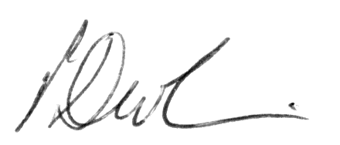

Paul Devlin
Area Head Ranger Port Hills & Banks Peninsula



